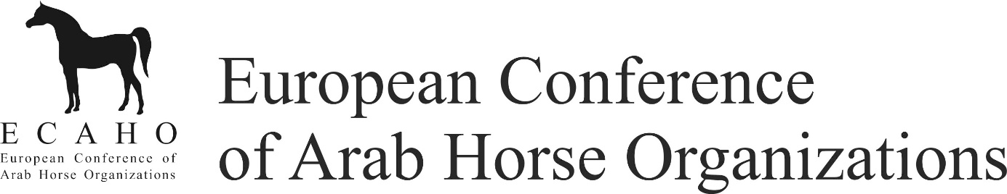

Trail Scribes Confirmation by Senior Sport Judge

Name of the event: Venue:
Country: Date:

ECAHO Sport show: YES NO Sport together with ECAHO Halter Show: YES NO
ECAHO Sport class together with open Sport event : YES NO

Number of Trail classes at this show:

Number of horses presented in each of these classes
Trail Classes scribe was on duty, please mark with O
Novice | Advanced | Master
Hand Trail
Novice | Advanced

Name, address, e-mail, mobile of the scribe:

Name, address, e-mail, mobile of the Senior Judge:

License:

Positive: YES NO

Date: Signature of Senior Judge:

To be sent immediately after the show to Chairman of EAHSpC Elisabeth Chat : info@chat-horses.at, cc to: the Executive Secretary of ECAHO: ECAHO Office, Zuzana Slavíková, Na Blatech 242, CZ-27711 Libis, Czech Republic
Phone +420 602 876 396, zuzana.slavikova@ecaho.org

