Title, logo, date of show, closing date of entries, etc.
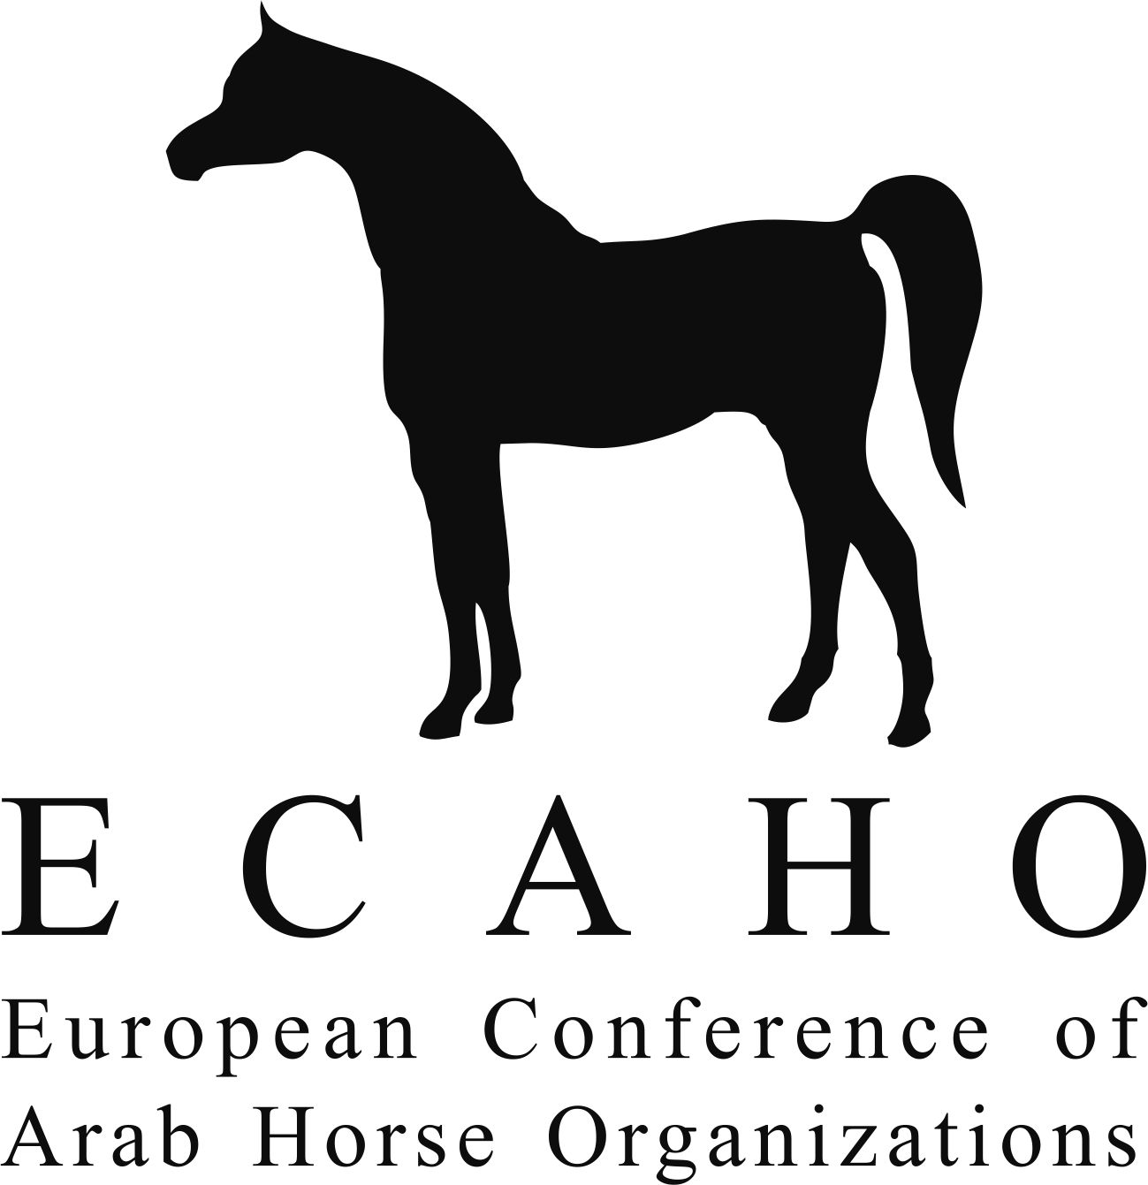

This show is affiliated with the European Arab Horse Show Commission
Affiliation No.
Xxx–xx-Country

ENTRY-FORM (only one horse per form)

Owner:_________________________________________________________ Country: ______________________________________

Address:_______________________________________________________________________________________________________
Tel.: _________________________________________ E-mail:___________________________________________________________
Breeder:_______________________________________________________________Country: ________________________________

By the closing date of entries, the horse is registered in the studbook of: |  |  |  | Country: | Studbook / Association | Reg. No.
Class: | Name of the horse: |  | Sire: | S | I, the undersigned person, engage that I and my employees and assistants hold entire responsibility for the horse entered and I accept without restriction the statutes, regulations and jurisdiction of ECAHO. Furthermore, concerning the horse entered, I agree to declare any actual and/or apparent conflict of interest of myself and/or my employees and/or assistants with the judges.  O There is an actual and/or apparent conflict of interest with judge:  _______________________________________  O There is no conflict of interest with any judge
 |  |  |  | D
 | Date of birth: |  | Dam: | S
 | Sex: | Colour: |  | D
Qualifications: |  |  |  |  | Name of the person who signs the form:  ________________________________________  Address (incl. country):  Tel.:_____________________________________  E-mail:___________________________________
Pregnant mares (tick if applicable):
☐ Mare is pregnant Last date of service: ___________________________
Photocopies of the presently valid registration documents are enclosed.
This entry form is not valid without signature and the full contact details of the person who signs it.
The person responsible for the horse is the registered owner or the lessee, but the person who signs the entry form, the handler, and other support personnel including but not limited to grooms and veterinarians may be regarded as additional persons responsible if they are present at the event or have made a relevant decision about the horse.
Capacity in which you sign (owner, trainer, assistant, other – please state):
Date & Signature:

Effective as of 1st Jan. 2020. This form is available at www.ecaho.org (Download).

